Words for Dark Time
By Fly 2020

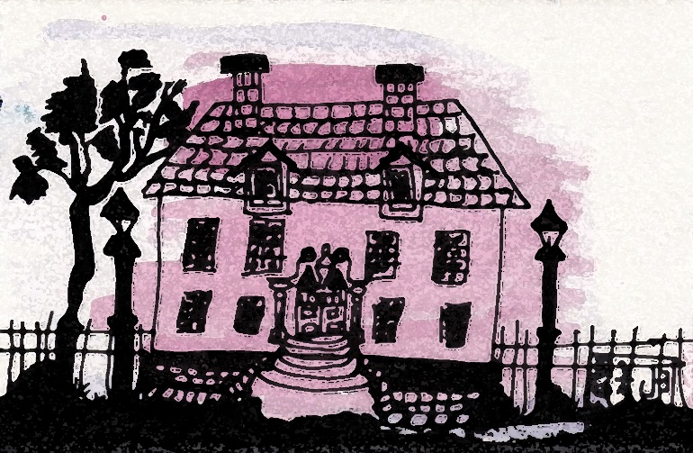

For Everyone Who is Afraid of Dark Time

Dark Time

Prayer
Read this with the light that radiates from your own good life. It is offered to you in this manner because my own good life keeps me away. You are there and I am here. I write this prayer to be with you.
Regard it as you regard a candle in a dark room.
When you lose the light you sometimes feel afraid. When you enter a darkened room, it is harder to see the way you see in the light.
A struck match seems very bright in the dark but sometimes even match-light cannot help.
The dark seems too big, too immense sometimes especially when you feel lost. You can’t find things in the dark and often you feel you are misplaced as well. And sometimes when the fear-mongers really, really frighten you, you begin to feel you are nowhere to be found. Everything in your own good life gets mislaid and you lurch against odd and unrecognizable shapes.
It’s as simple and as difficult as that.
All that you need is hidden in everything right where you are. It requires that you look for what is there.
The light is never in darkness.
To see in the dark the way you see in the light is not possible. The dark is not about seeing the way you see in the light. Darkness requires some other way to see. Listen and touch things with your fingertips. Feel your way to what is nearby. Stay still and listen.
When you feel alone the dark sometimes feels worse. This feeling spawns a need to touch something like the satiny edge of an old blanket or a dear dog-eared pillow.
It’s not necessary to move very much, but you might get startled by the things that appear in your mind’s eye. You might remember some cruel words or even just feel the ache in the back of your throat or that inexplicable twinge in your belly.
You may even pull the covers over your face to hide in the dark from feeling lonely. Oddly everything is included in the darkness, nothing gets pinned down or picked on or left out because you see it doesn’t belong there. In the dark everything gets to stay.
There are times every day you are in the dark. Much of your own body is in the dark and all the parts seem to work just fine for a time. And then one day everything joins together with the dark.
The dark slows you down when the moon becomes visible. Sometimes other planets and stars come out as well. The dark exposes what couldn’t be seen in the light. The planets and stars are always there.
You are more uncertain and hesitant in the dark, I know. It’s because you don’t want to bump into anything or disturb what is living in the dark. It is just the way the dark is, it helps you yield and recollect the things that reflect, like Venus and the Milky Way. And sometimes when you see the dark, you wobble. A little tremble scurries across your skin and you are not sure what is happening. That is the wobble!
Your world may seem very dark all the time. But that is not the true situation. It is only dark some of the time.
It does take time to adjust to the dark. It takes a little fiddling in the baby talk that seems to occur.
The baby mutters, “I don’t know, I don’t like it, NO! I don’t want this! I ‘m scared.” When you hear the baby mutter remember the word, “nonsense.” It can be tormenting, I know but the word, “nonsense” helps to quiet the baby. It’s important to remember the word “nonsense.” Just say it to yourself very, very sweetly.
This is how it goes.
The edges along things disappear in the dark which makes everything look bigger and fiercer. The mind adds stuff to things. And it is easy for you to be more afraid. It’s the kind of fear where you want to hide or run. Sometimes when you feel this way you want to take someone’s hand and hold it real tight but sometimes there isn’t any hand to hold and then you feel worse.
You may find a strong pull to search for a light switch or the string hanging from the ceiling. You begin to think and convince yourself that you will die if you stay in the dark. You probably do this because you might believe finding a light switch will end the darkness.
Light and dark are not at odds.
Everyone is afraid of the dark. Even dogs and cats are afraid. Your neighbors are afraid. It’s why there are so many lights outside. Everyone is trying get rid of the dark. The lights are a trick. You may think the dark is gone. But it is not gone.
You don’t need to know anything at all to be in the dark.
You may sometimes feel compelled by strong desires to get out of the dark. That’s what you do. Somehow you begin to draw some conclusions in order to feel less afraid. Deductions, inferences and assumptions are all attempts to get rid of the darkness and find some light. These flashing compulsions give you a little relief but ultimately you find yourself failing and still in the dark.
Once you believe you are a failure you might conclude foolish things about yourself and the dark. Things like “the only helping hand is the one at the end of my arm.” Or “I really am alone.” Or “I am not worthy.” Or “I made a mess of things and no one loves me.” These flash bulbs popping in your mind are attempts to beat the dark even though they lead to feeling worse. This way does not help you in the dark.
There is no getting rid of the dark. Nothing will end it. Not even when you die.
It helps just a little to remember mostly everyone is afraid of the dark. And everyone is trying to lessen the dark by installing lots of lights.
Sadly, these lights make you feel insecure and do not help you realize that light and dark are not enemies.
The dark is still dark.
Your fear and strong desires to get out of the dark lead you to try something. It’s not a fault, it’s your natural response. Natural responses are natural responses.
When you see what is going on you don’t trust it because you want something else to be going on. This strong desire for something else is particularly robust in the dark.
Often you look away and wish over and over, that hate will dispel the darkness. You chant, “I hate the dark! I hate the dark!” Nonetheless, the dark is still the dark and all the wishes won’t change it. Actually, the wishes of hate are fear-mongers. You just feel more afraid.
Please take a deep breath and ask out loud “what is really going on here?”
All that happens proves what is true.
You are surrounded by proof even though your deductions, inferences and assumptions make what is really going on hard to meet. But don’t worry. Your conclusions do nothing to change the truth. The dark despite your efforts is still there. The dark comes to expound dark. It flowers as only as dark flowers.
The dark sustains itself despite your confusion and fear. It won’t go away. The light merely shows off the dark.
You need not wish to be anywhere else. Be in the dark. Maybe even cheer a little bit when you find yourself there. You now know where you are. Rejoice! Repeat, “I am in the dark!” “I am in the dark!” The dark utters. You need not wish for where you are to be different than what it is.
Where you are is where everything you need is.
All of the dark is there.
Meet the dark without all those deductions, judgments, and criticisms.
Foolish conclusions about yourself and the dark do not help. It is not the language of darkness although you may think it is because every night you repeat the same fear-mongering chants.
There is no way to get rid of the dark. The dark is a place of rest that’s why everyone goes to bed at night.

Rest in dark.

________

